Given the root of a binary search tree and an integer k, return true *if there exist two elements in the BST such that their sum is equal to* k, *or* false *otherwise*.

**Example 1:**

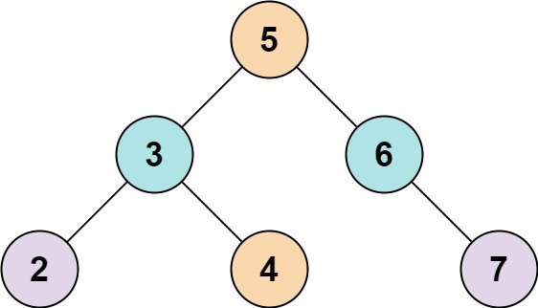

Input: root = [5,3,6,2,4,null,7], k = 9  
Output: true

**Example 2:**

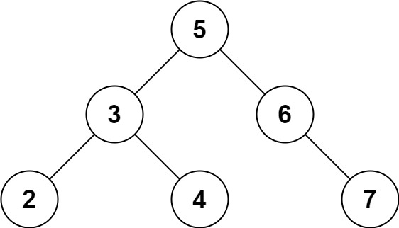

Input: root = [5,3,6,2,4,null,7], k = 28  
Output: false

**Constraints:**

* The number of nodes in the tree is in the range [1, 104].
* -104 <= Node.val <= 104
* root is guaranteed to be a **valid** binary search tree.
* -105 <= k <= 105